**Ideation Phase**

**Empathize & Discover**

|  |  |
| --- | --- |
| **Date** | 16 june, 2025 |
| **Team ID** | **LTVIP2025TMID41921** |
| **Project Name** | Project – TrafficTelligence : Advanced Traffic Volume Estimation with Machine Learning |
| **Maximum Marks** | 4 Marks |

The purpose of the Empathy Map Canvas is to help teams develop a shared understanding of the user by focusing on their experiences, behaviors, and emotions. It goes beyond basic demographics and looks into what truly drives the user — what they say, think, feel, and do. This tool is especially useful in product design, marketing, and user research, as it uncovers hidden needs and pain points that may not be obvious at first glance. By organizing insights visually, teams can align their strategies around real user perspectives, ultimately leading to more user-centered solutions and better decision-making.

**Empathize Phase vs. Empathy Map Canvas**

| **Aspect** | **Empathize Phase** | **Empathy Map Canvas** |
| --- | --- | --- |
| **Definition** | The first stage of Design Thinking where you understand the users deeply. | A collaborative tool used to visualize what you know about the user. |
| **Purpose** | To gain insights into users' needs, behaviors, pain points, and motivations. | To summarize and map out user attitudes and experiences in one visual layout. |
| **Goal** | Build empathy and define real user problems. | Understand the user's perspective clearly and concisely. |
| **Methods Used** | - Interviews  - Observations  - Surveys  - Shadowing | - User Interviews  - Brainstorming sessions  - Notes from field research |
| **Focus Areas** | Emotions, thoughts, context, pain points, and goals of users. | Says, Thinks, Does, Feels, Pains, Gains |
| **Format** | Narrative, raw research data, observation logs, user stories | Visual framework divided into 6 main sections |
| **When to Use** | At the start of a design or innovation project. | After conducting initial user research, during synthesis of insights. |
| **Output** | Empathy maps, user personas, insight statements. | One-page canvas that helps align teams on user understanding. |

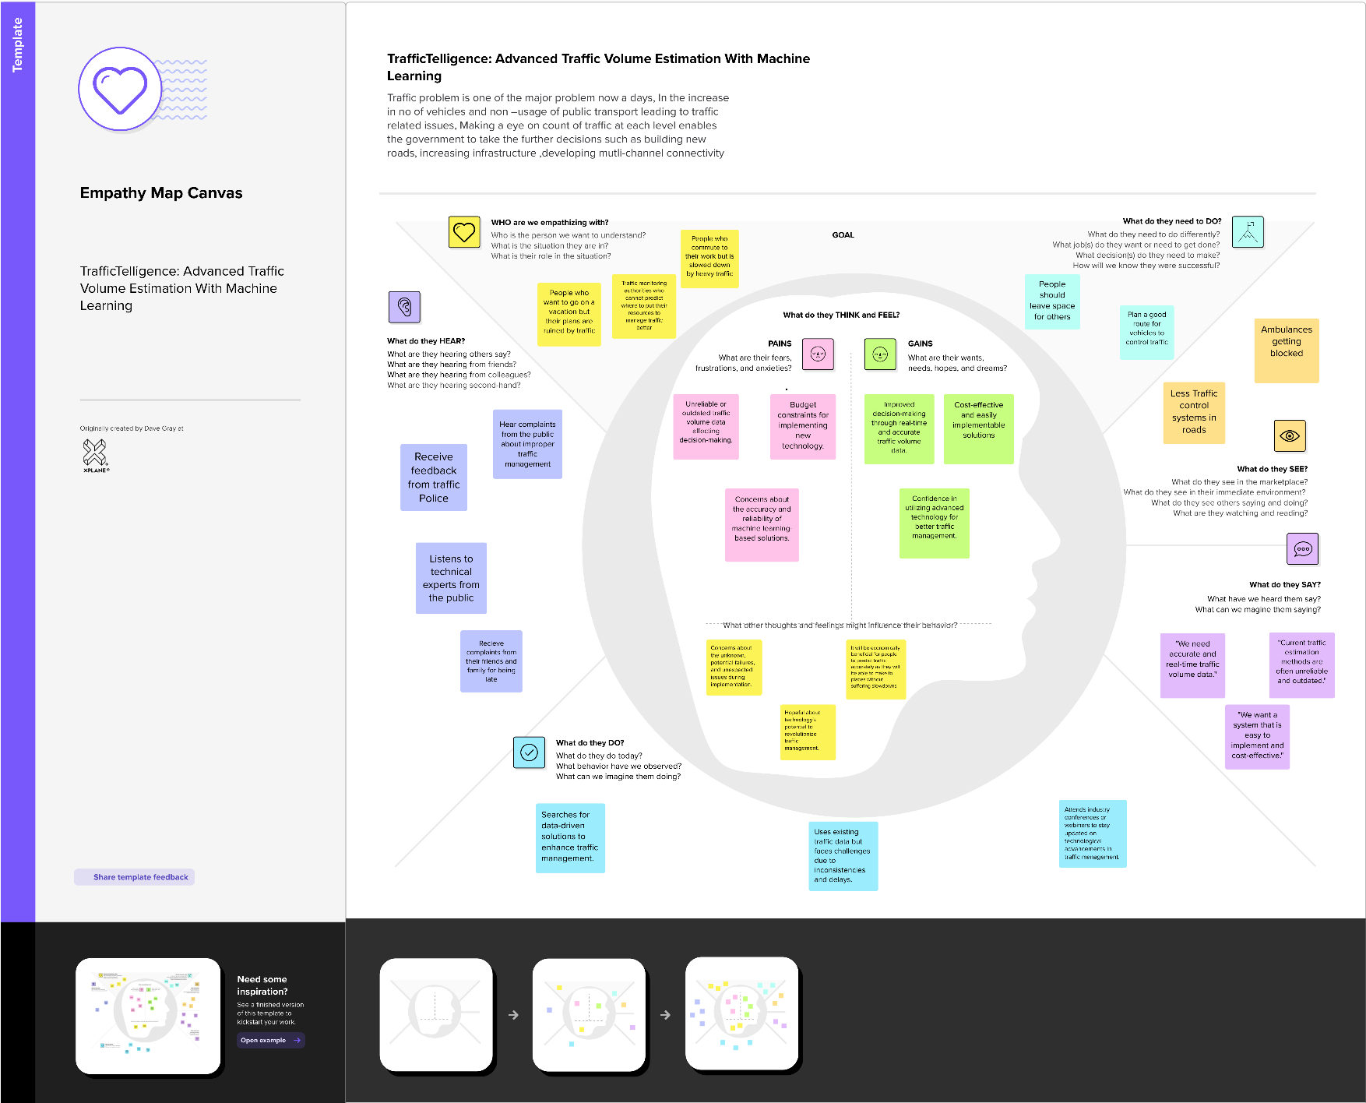**Empathy Canvas Map for the Project:**